# Another View

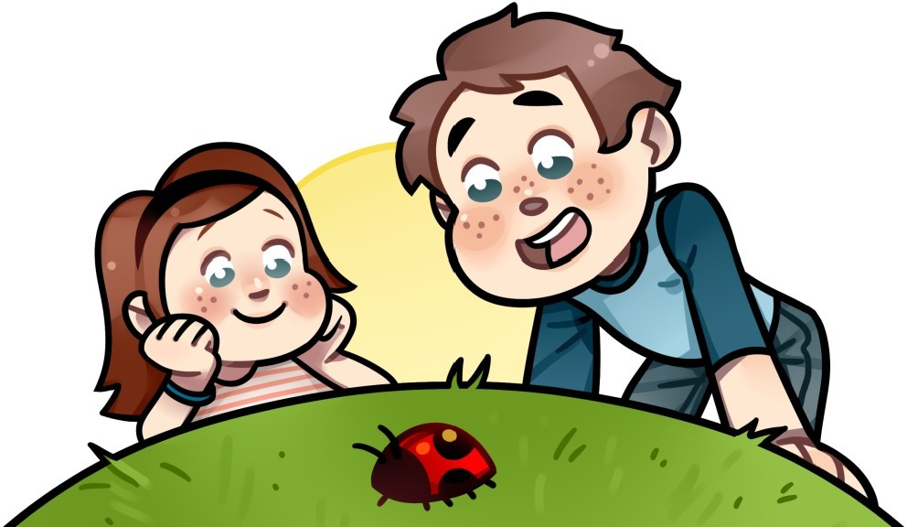One misty morning, Chloe and Joey were looking around their backyard. They were sitting on the grass. Joey saw a rock with little plants on it. “Look at that mossy green rock!” Joey cried.

“That is not a rock,” Chloe said. “It’s a dinner table for snails.” A snail inched over to the rock to munch on the plants.

Next, Joey saw a leaf. “Look at that pretty yellow leaf!” Joey cried. “That is not a leaf,” Chloe said. “It’s a blanket for beetles.” A beetle crawled under the warm leaf.

Then, Joey saw a flower. “Look at that red flower!” Joey cried. “That is not a flower,” Chloe said. “It’s a shower for worms.” A worm played in the water under the flower as dewdrops dripped from the petals. “Look at that wild mushroom!” Joey cried.

“That is not a mushroom,” Chloe said. “It’s an umbrella for spiders.” A spider knit a web under the mushroom away from the mist. Finally, Joey saw a stick. “Look at that squiggly–” Joey stopped. If he called it a stick, Chloe would say it was not a stick. So, Joey cried, “Look at that squiggly ladybug ladder!”

Chloe grinned at Joey and said, “*Now* you're seeing things from another point of view!”